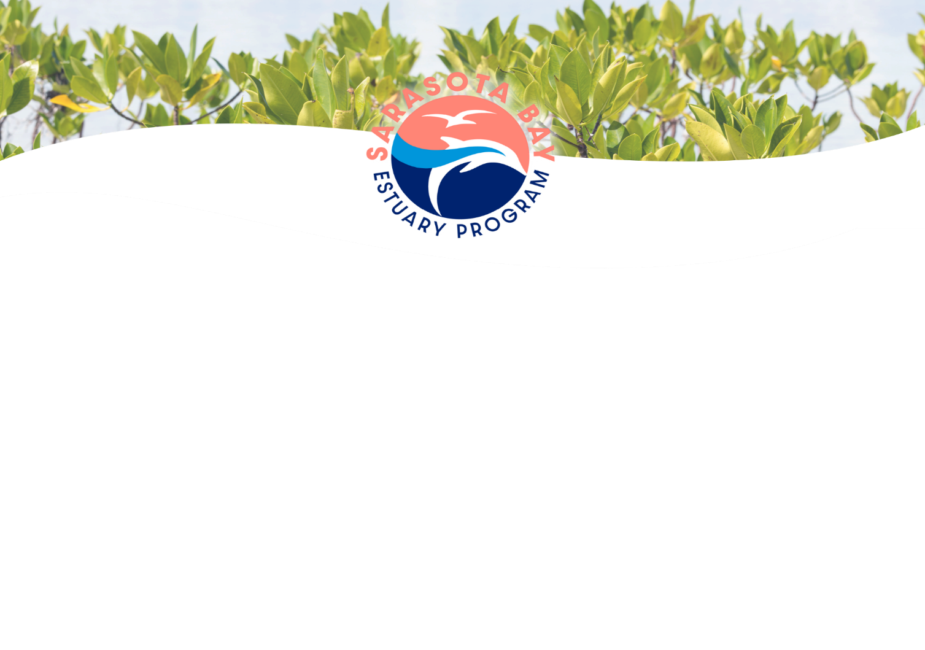

WATER QUALITY CONSORTIUM

Wednesday, April 3, 2024, 9:00 a.m.
Join us: https://meet.goto.com/807319349

ATTENDEES:
Dave Tomasko, SBEP Paul Semenec, Sarasota County
Jay Leverone, SBEP Brooke Langston, Sarasota County
Cheryl Dexter, SBEP Isaac Brownman, Town of Longboat Key
Mike Wessel, ESA Verne Hall, City of Sarasota
Jon Perry, ESA Kevin O’Donnell, FDEP
Becky Allenbach, EPA Ken Weaver, FDEP
Felicia Burks, EPA Kevin Petrus, FDEP
Greg Blanchard, Manatee County Benjamin Ralys, FDEP
Kevin Morris, Manatee County Steven Kelly, FDOT
Heather Bryen, Sarasota County Stephen Suau, Progressive Water Resources
Chelsea Dinon, Sarasota County Tiffany Busby, Wildwood Consulting

9:00 WELCOME AND INTRODUCTIONS D. Tomasko, SBEP
9:15 PROTECTING WATER QUALITY IN SARASOTA BAY: D. Tomasko, SBEP
IMPLICATIONS OF CURRENT TRENDS
Dr. Tomasko reviewed the watershed evaluation process in Florida based on the 1997 Watershed Protection Plan. He outlined the process of data collection, comparison of the data to water quality standards, the Impaired Waters Rule, adopted total maximum daily loads (TMDLs), and the basin management action plan (BMAP) step to pursue restoration. He noted that in Sarasota Bay the reference-period approach is used to establish the loading limits over which the bay has exceeded its assimilative capacity.
He commented that in 2021 the Water Quality Consortium decided to implement a Reasonable Assurance Plan and a State of the Bay Report Card was developed, using four metrics: total nitrogen (TN), chlorophyll-a, macroalgae abundance, and seagrass acreage, with a reference period of 2006 to 2012. During that reference period, there were lower levels of TN and Chlorophyll-a, and less macroalgae (compared to the next seven-year period) and the bay experienced a 28% increase in seagrass coverage. The Report Card is updated annually, using color coding to indicate water quality conditions. He added that recently the FDEP has concluded that none of the open waters of Sarasota Bay are considered impaired for nutrients.
Dr. Tomasko commented that in February 2024, the SBEP Policy Board approved pursuing a Water Quality Protection Plan, rather than a RAP. In this process, future load increases will be estimated, load reductions needed to “hold the line” would be developed, load reduction projects would be identified, and a public-facing document would be created to ensure timely completion of the required actions.

10:00 PROVIDING AN ACTIONABLE PLAN FOR THE FUTURE PROTECTION M. Wessel, ESA
OF SARASOTA BAY ESTUARIES
Mr. Wessel reviewed the proposed approach to protect waters, to include projected future impacts, limiting pollutant loadings, and to create an action plan database. He noted that there is no formal process to adopt a water quality protection plan in Florida. He reviewed the increased production of treated wastewater and how the county has decommissioned older wastewater treatment facilities (WWTFs) and sent effluent to more advanced facilities, increasing the wastewater volumes at those facilities.
He noted that the pollutant model existing conditions have been updated through 2022. He provided an AWT scenario where all the facilities treated to AWT, eliminating all septic systems, sending the effluent to sewer and eliminating all spills. In Little Sarasota Bay and Roberts Bay, all the necessary load reductions from wastewater improvements would be achieved. Other areas would require stormwater retrofits.
Dr. Tomasko invited consortium members to provide feedback or ask questions via email.
10:30 ESTIMATING FUTURE POLLUTANT LOADINGS: OPEN DISCUSSION J. Perry, ESA
Mr. Perry reviewed the project database and how a future loading scenario could be developed collaboratively with our local partners over the future years into decades. Dr. Tomasko added that the list should offset future anticipated loads.
Mr. Semenec noted that Sarasota County has a public-facing project portfolio as part of their stormwater plan, wherein all listed projects are scored and prioritized. As funding becomes available, they move projects from the portfolio to their capital improvement plan (CIP).
Mr. Perry reviewed different scenarios on how the future loads could be conceptualized, adding that other factors to consider are hydrologic conditions and sea level rise.
Ms. Busby commented that the 1000 Friends of Florida geodatabase for future growth/sprawl through 2070 may be a useful resource, adding that local information is likely the most accurate. She added that the vulnerability study underway for Sarasota County may have some rainfall scenarios for future scenarios. Dr. Tomasko added that changes in air and water temperatures are being noted, but not rainfall.
Dr. Tomasko commented that we are on track to produce the plan over the next seven months, that Sarasota Bay is improving, and it is expected that seagrass results will reflect those improvements. He commented that adding stormwater treatment in older neighborhoods should be prioritized.
11:00 PUBLIC COMMENT: There was no public comment. D. Tomasko, SBEP
11:01 MEETING ADJOURNED

THIS MEETING IS OPEN TO THE PUBLIC

